To
M/s. Loops Automation

Dear Sir,

05th Feb 2026

We refer to the finalized techno-commercial discussions and are pleased to submit our contract documentation CNJ/142854/01/2026 based on the approved input provided by your team.
This cover letter is issued to ensure complete commercial and contractual clarity at the time of award, and to briefly outline our execution and monitoring methodology for smooth project delivery.

This communication is intended to ensure complete alignment and mutual understanding prior to any further contractual progression and shall be read in conjunction with our submitted quotation.

The quotation is strictly based on a fabrication-only scope, to be executed at C&J Gulf Equipment Manufacturing LLC’s approved fabrication facility. All activities are governed by clearly defined scope boundaries, responsibilities, exclusions, and change control mechanisms as detailed in the Master Fabrication Template, to avoid scope ambiguity, uncontrolled variations, and post-award commercial exposure.

Scope of Work – Fabrication Only

Our proposal is strictly limited to shop fabrication activities only, to be executed at C&J Gulf Equipment Manufacturing LLC’s fabrication facility in Musaffah, Abu Dhabi. The scope includes structural steel fabrication, piping spool fabrication and welding, applicable NDT and inspection, preparation and submission of standard QA/QC documentation, packing, and ex-works delivery including loading onto the Client’s truck, as detailed in the enclosed techno-commercial offer.
Any activity, supply, or service not expressly stated in the quoted scope—such as engineering and design responsibility, preparation of fabrication drawings, site installation, commissioning,

FAT/SAT, electrical and instrumentation works, transportation to site, or post-dispatch modifications—shall be deemed excluded from our scope and price, unless explicitly included in the Purchase Order.

Drawings, Design Responsibility & AFC Status

All detailed fabrication drawings, engineering design, and technical responsibility shall be provided by the Client. Fabrication shall commence only upon receipt of Approved-for-Construction (AFC) drawings. Any revision, modification, or change to drawings or specifications after commencement of fabrication shall be treated as a variation, with corresponding cost and schedule impact subject to mutual agreement prior to execution.

Quantity, Weight Basis & Commercial Assumptions

The prices quoted are based on the estimated quantities, material grades, structural steel weights, and piping welding inch-dia stated in our offer. Any increase arising from drawing revisions, design development, additional scope, or Client-initiated changes shall result in a proportional adjustment of price and delivery schedule through an agreed Variation Order.

Inspection, Testing & Final Acceptance

Inspection and testing shall be carried out at our workshop during normal working hours in accordance with standard fabrication practices and agreed inspection requirements. Client or third-party representatives may witness inspections with prior coordination.
Shop inspection and acceptance shall be deemed final for invoicing and dispatch, and C&J shall not be responsible for any claims, modifications, or additional requirements identified after dispatch and signing of the release note.

Delivery Terms & Risk Transfer

Delivery shall be on an Ex-Works basis from C&J’s workshop. Risk and responsibility shall

transfer to the Client upon loading of the fabricated items onto the Client’s truck. Transportation to site, off-loading, site handling, and installation activities are outside the scope of this proposal.

Schedule & Prerequisites

The fabrication schedule shall commence and be completed within the period stated in our offer, only upon receipt of advance payment and AFC drawings. Any delay in meeting these prerequisites shall automatically extend the delivery schedule without penalty or liability to C&J.

Payment Terms, Warranty & Liability

Payment terms shall be as detailed in the enclosed proposal. The workmanship warranty shall be valid for 12 months from the date of dispatch and shall be limited strictly to the scope of work executed by C&J
C&J’s total liability under this contract shall be limited to the contract value, and no indirect, incidental, or consequential damages shall apply.

Validity & Contractual Basis

This offer shall remain valid for 30 days from the date of submission. Upon award, the Purchase Order, approved scope, agreed drawings, and this techno-commercial proposal shall together form the basis of the contract.
We trust the above clarifies our scope, responsibilities, and commercial basis. Should you require any clarification or additional information, please feel free to contact us. We look forward to your valued order and to executing this project to your satisfaction.

Should you require any clarification or alignment discussion on the above, we remain available for coordination.

We appreciate the opportunity to engage with Loops Automation and look forward to your confirmation and continued professional association.
Yours faithfully,

For C&J Gulf Equipment Manufacturing LLC.
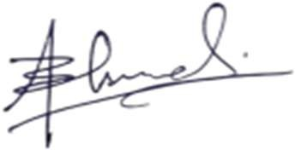

Bilal Ahmed
Cost & Estimation Engineer.
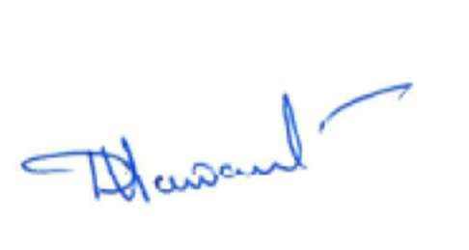
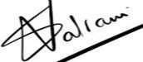

Datta C. Sawant Subash Valrani
Sr. Mechanical Engineer Business Unit Head

